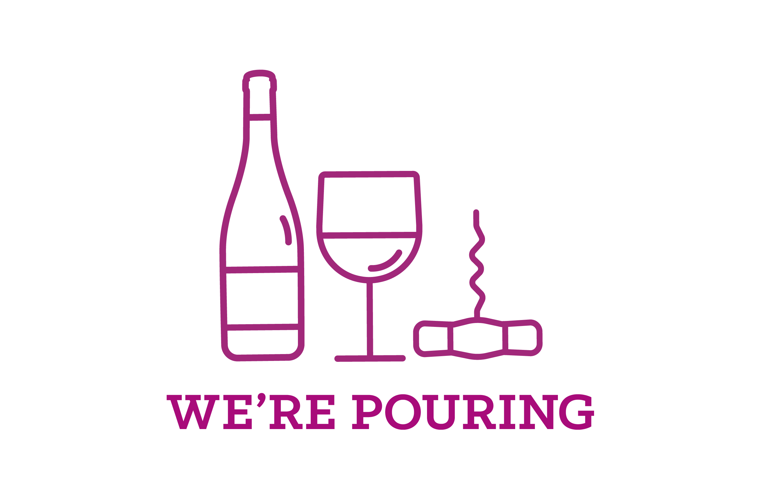
19 Crimes

Cali Gold Sparkling, California
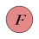Cali Red Blend, California
Cali Rose, California
19 Crimes Martha Chard, California
19 Crimes Pinot Noir, SE Australia
19 Crimes Cabernet Sauvignon, SE Australia

High Noon

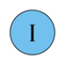Black Cherry
Grapefruit
Lemon
Lime
Mango
Passionfruit
Pineapple
Watermelon

E & J Gallo

- LaMarca Prosecco
LaMarca Prosecco Rose
Franciscan Chardonnay
Mark West Pinot Noir
Estancia Cabernet Sauvignon
Nobilo Sauvignon Blanc

Trinchero Family Estates

Seaglass Chardonnay
Seaglass Pinot Grigio
Seaglass Pinot Noir
Seaglass Riesling
Seaglass Sauvignon Blanc
Seaglass Rose

The Wine Group

Chloe Chardonnay
Chloe Prosecco
- McManis Viognier
- McManis Cabernet Sauvignon
Tribute Sauvignon Blanc
Tribute Pinot Noir

Prestige Beverage Group

- Dona Paula Estate Malbec
Dona Paula Cabernet Sauvignon
Overstone Sauvignon Blanc
Risata Blueberry
Risata Peach

Bogle

- Bogle Pinot Noir
Bogle Rose
- Bogle Old Vine Zinfandel
- Bogle Phantom Chardonnay
- Bogle Phantom Red Blend

Copper Cane

- Elouan Chardonnay
- Elouan Pinot Noir
- Elouan Rose
- Boen Tri App Pinot Noir
- Boen Chardonnay
1821 Wine & Spirits

Castello di Poggio Moscato
Castello di Poggio Peachy Dreams
Castello di Poggio Pinot Grigio
Primo Amore Moscato
Arel Group

Candoni Moscato d' Italia
Ricco Blueberry
Ricco Mango
Ricco Semi Sweet Red
Ricco Peach
Okoboji Wines

Party Can Triple Spice Margarita 1.75ml
Coastal Charm Pumpkin Spice
Frisk Riesling
Innocent Bystander Pink Moscato
Raw Bar Vinho Verde
House of Brown Chardonnay
Highlands 41 Black Granite Red Blend
Mary Taylor (AnnaMaria Sala) Sicilia Rosso
Caiden Block Nine Cabernet Sauvignon
Belasco Llama Cabernet Franc
- Lapis Luna Zinfandel
Okoboji Wines

Stella Rosa Asti
Stella Rosa Prosecco
Stella Rosa Pinot Grigio
Stella Rosa Cranberry
Stella Rosa Lemon Lime
Stella Rosa Blackcherry
Stella Rosa Blackberry
San Antonio Fruit Farm Blackberry Orange
San Antonio Fruit Farm Strawberry Guava
San Antonio Fruit Farm Peach Passion Fruit
Eola Hills

Eola Hills Cabernet Sauvignon "Classic"
Eola Hills Chardonnay "Classic"
Eola Hills Pinot Gris "Classic"
- Eola Hills Pinot Noir "Classic"
Eola Hills Red Blend "American Red" NV
Eola Hills Riesling "Classic"
Eola Hills Rose "Classic"
Eola Hills S.Blanc "Classic"
Dimitri Wine and Spirits

Cleto Chiarli Lambrusco Ambile – Emilia Romagna, Italy
La Valentina Montepulciano – Abruzzo, Italy
Thomas Goss Shiraz – McLaren Vale, Australia
Ramsay Cabernet Sauvignon – North Coast, California
Adami Garbel Prosecco – Veneto, Italy
- Vietti Moscato d’Asti – Piedmont, Italy
Pitars Sauvignon Blanc – Friuli, Italy
- Pannonica White Blend – Burgenland, Austria
Alois Lagader Chardonnay – Veneto, Italy
Constellation

- Kim Crawford Prosecco
- Simi Brightful Chardonnay
Simi Editors Collection Rose
- Meiomi Red Blend
Robert Mondavi Private Selection Naturally Sweet Pinot Noir
Woodbridge Soda Cocktails
Ruffino Lumina Pinot Grigio
Constellation Aspira

Unshackled Chardonnay
Unshackled Pinot Noir
Blindfold Blanc de Noir
Simi Russian River Pinot Noir
- Simi Landslide Cabernet
- Robert Mondavi Winery Napa Cabernet Sauvignon
Foley Family Wines

- Ferrari-Carano Fumé Blanc
- Ferrari-Carano Chardonnay
- Chalk Hill Sonoma Coast Chardonnay
- Acrobat Pinot Gris
Acrobat Pinot Noir
- Banshee Cabernet Sauvignon
Terlato Wines International

Federalist Lodi Cabernet Sauvignon
Federalist Lodi Chardonnay
Federalist Bourbon Barrel Red Blend
Federalist Bourbon Barrel Zinfandel
Seven Daughters Moscato
- Riondo Prosecco

Delicato Family Wines

Noble Vines 242 Sauvignon Blanc
Relax Riesling
Coppola Prosecco
1924 Port Barrel Pinot Noir
3 Finger Jack Red Blend
Z. Alexander Brown Cabernet Sauvignon
Ste Michelle Wine Estates

Chateau Ste. Michelle Luxe Brut
14 Hands Unicorn Rosé
Liquid Light Sauvignon Blanc
Santa Cristina Toscana Rosso
Chateau Ste. Michelle Indian Wells Red Blend
Chateau Ste. Michelle Columbia Valley Cabernet Sauvignon
Deutsch Family Wine & Spirits

Josh Prosecco
- Fleur de Prairie Rosé
The Crossings Sauvignon Blanc
Josh Reserve Buttery Chardonnay
Josh Reserve Bourbon Barrel Zinfandel
Josh Reserve Bourbon Barrel Cabernet Sauvignon
Madison County Winery

Rosato (dry rosé wine)
Phat Man (port style fortified wine)
Bourbon Barrel Red (red wine aged in bourbon barrels)
Gold (Pinot Grigio)
Raspberry Blanc (semi-sweet white grape wine infused with fresh raspberry)
Lollipop (sweet red wine)
Hall Wines

- HALL ‘Napa Valley’ Sauvignon Blanc 2019
HALL ‘Napa Valley’ Cabernet Sauvignon 2018
WALT ‘Sonoma Coast’ Chardonnay 2018
- WALT ‘La Brisa’ Pinot Noir 2019, Sonoma Coast
BACA ‘Double Dutch’ Zinfandel 2020, Paso Robles, Dusi Vineyard
Global Wines Iowa

- San Silvestro, Piemonte Barbera Ottone I° (2019)
- Poderi Dal Nespoli, Rubicone Sangiovese Merlot Nespolino (2019)
- Poderi Dal Nespoli, Rubicone Trebbiano Chardonnay Nespolino (2019)
- Zolo, Torrontés Estate Grown Mendoza (2021)
Veneto Committee — Iowa Sister States

- Bisson, Conegliano Valdobbiadene Prosecco Superiore DOCG Glera
- Tenuta Sant’Antonio Garganega/Chardonnay Scaia
- Tenuta Sant’Antonio Corvina Scaia
Jackson Family Wines - Classics

Kendall-Jackson Low Calorie Chardonnay
Kendall-Jackson Rosé
La Crema Sauvignon Blanc
Bootleg Red Blend
Silver Palm Cabernet Sauvignon
La Crema Monterey Pinot Noir
Jackson Family Wines - Select

Carmel Road Cabernet Sauvignon
Murphy Goode Sauvignon Blanc
Murphy Goode Rosé
Benvolio Prosecco
Carmel Road Chardonnay
Siduri Santa Barbara County Pinot Noir
Rodney Strong

Rodney Strong Charlotte's Home Sauvignon Blanc
Knotty Vines Chardonnay
Knotty Vines Pinot Noir
Upshot Red Blend
Rodney Strong Sonoma County Red Blend
Rodney Strong Sonoma County Cabernet Sauvignon
Winery Exchange

Bread & Butter Prosecco
Bread & Butter Chardonnay
Bread & Butter Pinot Noir
Chronic Cellars Suite Petite Petite Syrah
Jelly Jar Strawberry Rhubarb
Trapiche Broquel Cabernet Sauvignon
Jasper Winery

JW White
JW Rose
JW Red
Sangria
Mimosa
Vitis Distribution, LLC

Mi Terruno Expressions Sauvignon blanc
Mi Terruno Reserve Chardonnay
Mi Terruno Reserve Bonarda
Mi Terruno Reserve Cabernat franc
Mi Terruno Reserve Malbec
Korta Carmenre

Vitis Distribution, LLC

Coyote Sonoma Sauvignon blanc
Arbor Crest Baccus Chardonnay
Silven Ridge Pinot noir
Pech Merle Reserve Zinfandel
Arbor Crest Merlot
Mazzocco Cabernet sauvignon

Wall to Wall

Graham Beck Brut Rosé NV Methode Cap Classique (South Africa)
*Cleto Chiarli Centenario NV Lambrusco di Modena doc Rosado DOC (Italy)
* Scarpetta 2021 Pinot Grigio Friuli DOC
Cicada's Song 2021 Rosé de Var IGP (France)
Freak of Nature 2021 No Filtrado Rosado (Spain)
*Poggio Anima 2020 Lilith Primitivo-Salento IGP (Italy)
Cantina Zaccagnini 2019 il Vino dal Tralcetto Montepulciano d'Abruzzo DOC (Italy)

* = Available as part of the Winefest Wine Club!

